##### Program 1:

Write afunctionthatusesCASEstatementwhereifmonthly_valueisequaltoorlessthan4000,thenincome_levelwill be set to 'Low Income'. If monthly_value is equal to or less than 5000, then income_level will be set to 'AvgIncome'.Otherwise, income_levelwillbesetto'HighIncome'.

##### Procedure:

LOOP Syntax[begin_label:] LOOPstatement_list

ENDLOOP[end_label]

LOOPimplementsasimpleloopconstruct,enablingrepeatedexecutionofthestatementlist,whichconsistsofoneormorestatements, eachterminated byasemicolon

(;)statement delimiter. The statements within the loop are repeated until the loop is terminated. Usually, this isaccomplishedwithaLEAVEstatement.Withinastoredfunction,RETURNcanalsobeused,whichexitsthefunctionentirely.

##### Program 2:

WriteafunctionthatwilluseITERATEstatementwhichwouldcausethelooptorepeatwhileincomeis less than4000.Onceincomeisgreater thanorequalto 4000,would terminatetheLOOP.

1)

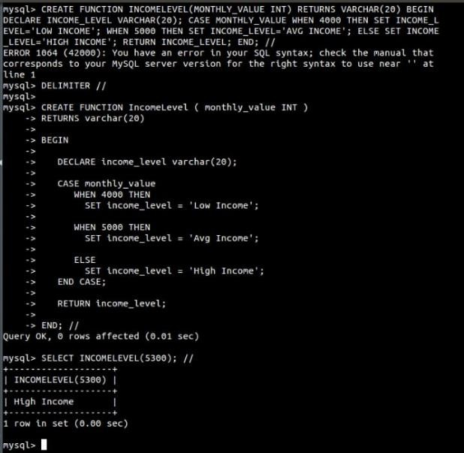

2)

